# TurkishExportal

[https://www.turkishexportal.com](https://www.turkishexportal.com/)

URLs to extract:

1. Machinery, Industrial Parts & Tools - <https://www.turkishexportal.com/Machinery-Industrial-Parts-Tools-Category-Path-5009?lang=en>
2. Home, Lights & Construction - <https://www.turkishexportal.com/Home-Lights-Construction-Category-Path-5008?lang=en>
3. Auto & Transportation - <https://www.turkishexportal.com/Auto-Transportation-Category-Path-5002?lang=en>
4. Electrical Equipment & Supplies - <https://www.turkishexportal.com/Electrical-Equipment-Components-Telecoms-Category-Path-5005?lang=en>
5. Electronics - <https://www.turkishexportal.com/Electronics-Category-Path-5004?lang=en>
6. Metallurgy, Chemicals and Plastics - <https://www.turkishexportal.com/Metallurgy-Chemicals-Rubber-Plastics-Category-Path-5010?lang=en>

Instructions:

1. When you click in one of the categories, you will be redirected to the actual products in this example, Waste Management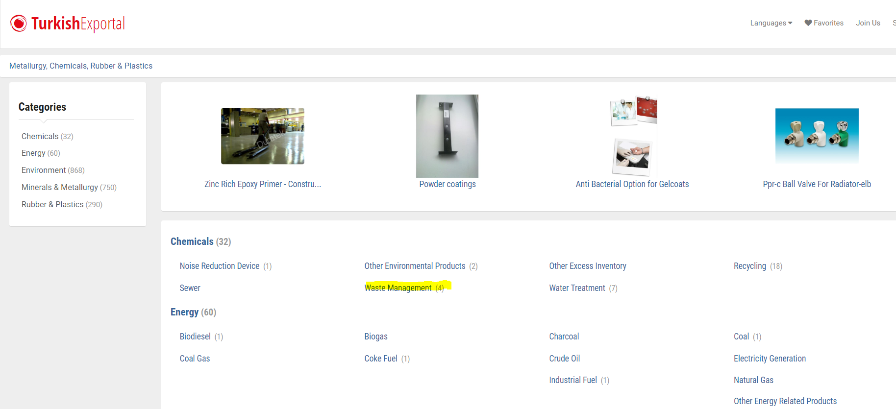
2. You’ll be redirected to the actual products

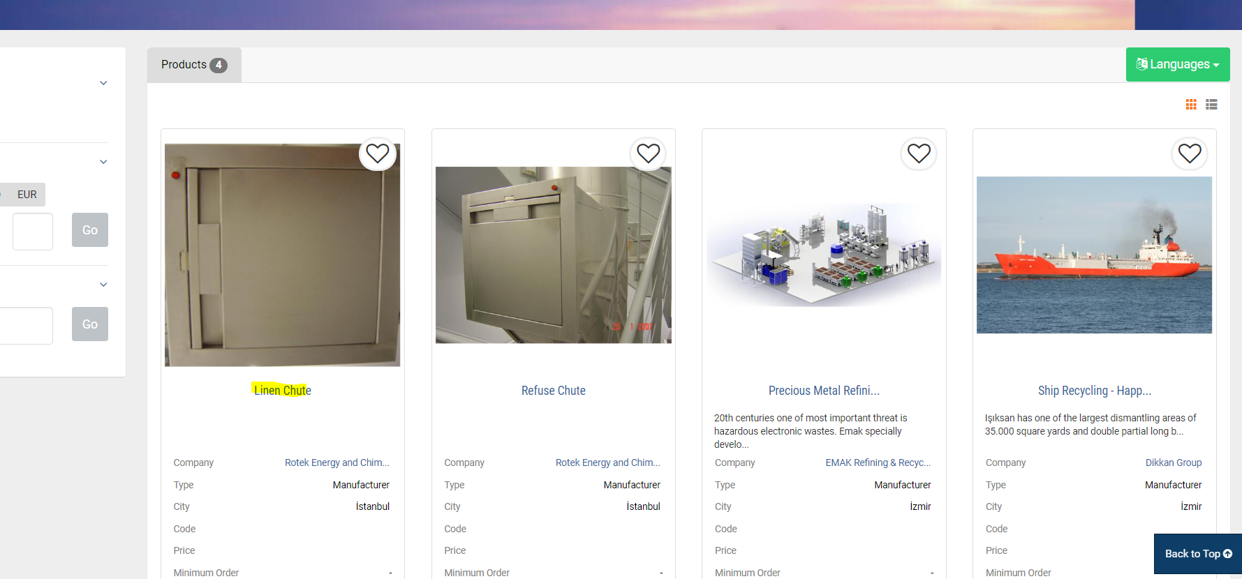

1. You’ll see this page, click on the Contact button to see a lot of important data

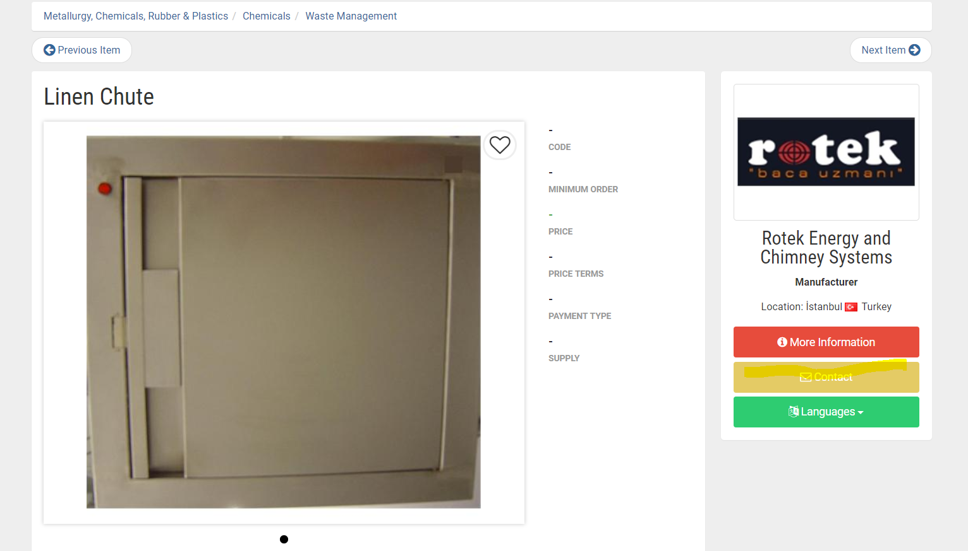

1. We will be interested in all the data in this page, Name, designation, Address, city, country, telephone, website, linkedin.

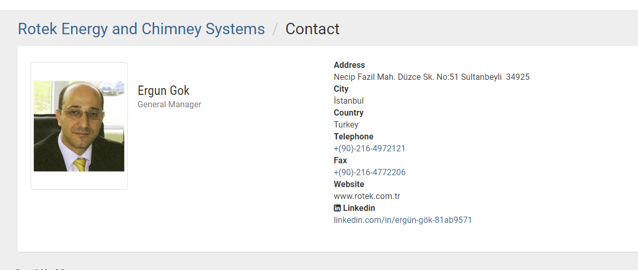

1. Also in the product section, if all the indicated products can be scraped will be good too.

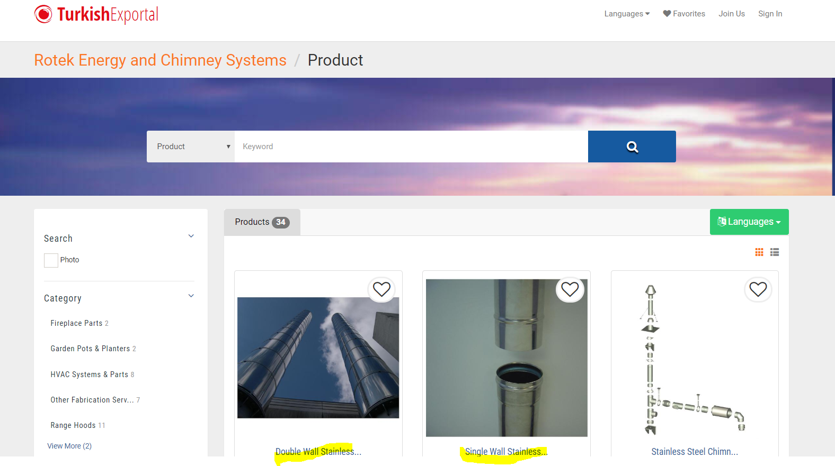

1. Lastly, the company description

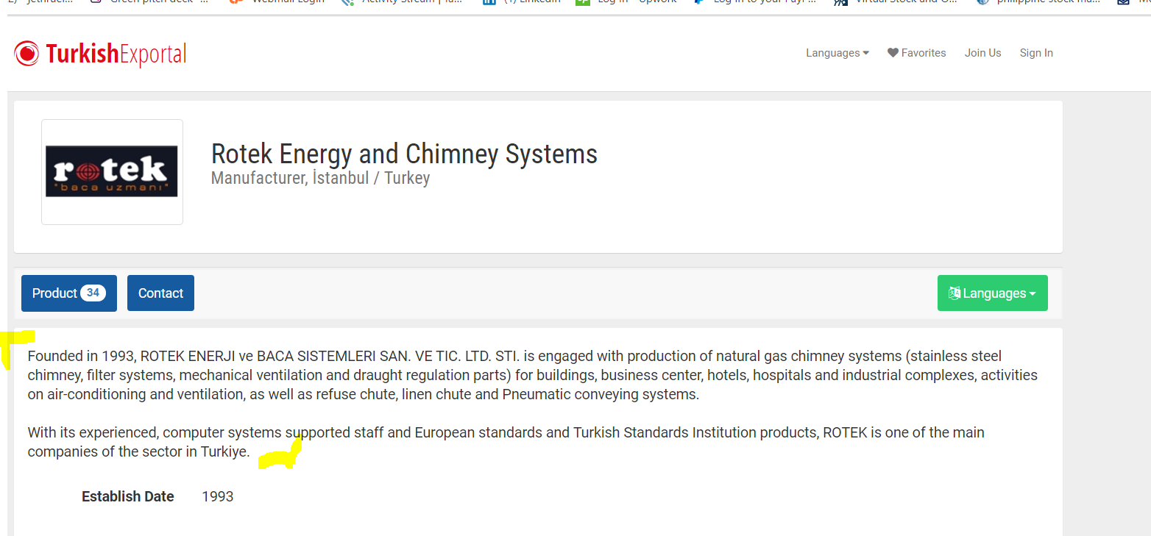

Thank you!